After SE Feedback

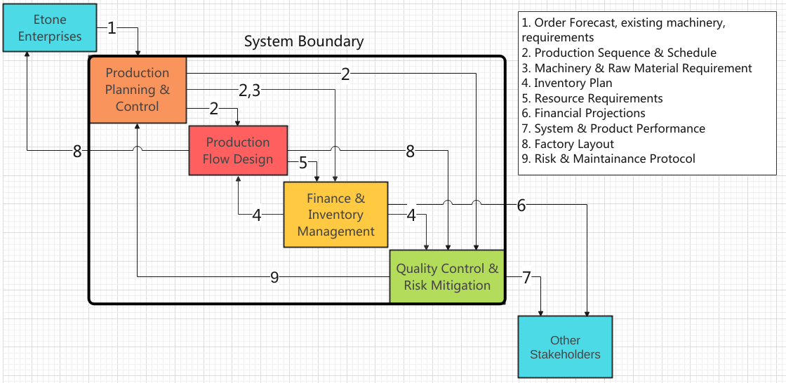

| Etone | 1 |  |  | 10 |  |
| --- | --- | --- | --- | --- | --- |
|  | PP&C | 2 | 2,3 | 2 |  |
| 8 |  | PFD | 5 | 8 |  |
| 6 |  | 4 | F&IM | 4 | 6 |
| 7 | 9 |  |  | QC&RM | 7 |
|  |  |  |  |  | Stakeholders |

1. Order Forecast, existing machinery

2. Production Sequence & Schedule

3. Machinery & Raw Material Requirement

4. Inventory Plan

5. Resource Requirements (land)

6. Financial Projections

7. System & Product Performance

8. Factory Layout

9. Risk & Maintenance Protocol

10. Performance Requirements

| Etone |  | 1 |  |  | 2 |  |  |
| --- | --- | --- | --- | --- | --- | --- | --- |
|  | Production System |  |  |  | 12 |  | 11 |
|  |  | PP&C | 3 | 3,4 | 3 |  |  |
| 7 |  |  | PFD | 6 | 7 |  |  |
| 8 |  |  | 5 | F&IM | 5 | 8 | 5 |
| 9 |  | 13 |  |  | QC&RM | 9 |  |
|  |  |  |  |  | 12 | Stakeholders |  |
|  | 10 |  |  |  | 12 | 11 | Suppliers &  Distributors |

1. Order Forecast, Existing Asset(machinery) List

2. Performance Requirements

3. Production Sequence & Schedule

4. Machinery & Raw Material Requirement

5. Inventory & Order (Machinery, Delivery etc.) Plan

6. Land & Resource Requirements

7. Factory Layout

8. Financial Projections

9. System & Product Performance

10. Raw Material

11. Manufactured Product

12. Failure

13. Risk & Maintenance Protocol

The orange interfaces are Materials. This includes :

* Raw Material
* Manufactured Product

The other interfaces are Information. This includes :

* Inventory Plans, Order Plan,
* Assets and Inventory
* Requirements
* Performance Reports, Financial Plans
* Production System Layout

The green interfaces are information interfaces activated when a failure occurs. This includes :

* Lack of workforce on certain days
* Lack of inventory
* Unexpected Machine Failure